### 

Error with Not existing instance profile in Elastic Beanstalk

Standard Operating Procedure

Date: 10/04/2024

Author: ABI F

Revision History

Introduction 1

Purpose of the Document

**Procedure** **2**

Troubleshooting the issue

**Resolution** **3**

Creating IAM profile

Add the platform with version and upload the sample code you need to run and click next

Configure service access

**References** **4.**

# Revision History

|  |  |  |  |
| --- | --- | --- | --- |
| Name | Date | Reason for changes | Version |
| ABI F | 10/04/2024 | First Draft | 1.0 |
|  |  |  |  |

# Introduction

## Purpose of the Document

This document provides a standard operating procedure (SOP) to troubleshoot and resolve the issue in which the clients are not able to connect to Error with Not existing instance profile in Elastic Beanstalk

# Procedure

## Troubleshooting the issue

If the Elastic Beanstalk is not responding to Existing instance profile, please follow the below steps

According to AWS security guidelines don’t allow an AWS service to automatically create roles with trust policies to other AWS services,

Because of these security guidelines, Elastic Beanstalk no longer creates a default aws-elasticbeanstalk-ec2-role instance profile.

## 3.RESOLUTION

So, if your AWS account doesn’t have an EC2 instance profile, you must create one using the IAM service. You can then assign the EC2 instance profile to the new environments that you create.

3.1Steps to be followed:

Creating IAM profile

Open IAM Console → In the navigation pane of the console, choose Roles and then create role → Under Trusted entity type, choose AWS service → Under Use case, choose EC2 → Choose Next →Attach- AWSElasticBeanstalkWebTier, AWSElasticBeanstalkWorkerTier, AWSElasticBeanstalkMulticontainerDocker → Choose Next → Enter a name for the role - aws-elasticbeanstalk-ec2-role → Choose Create role.

[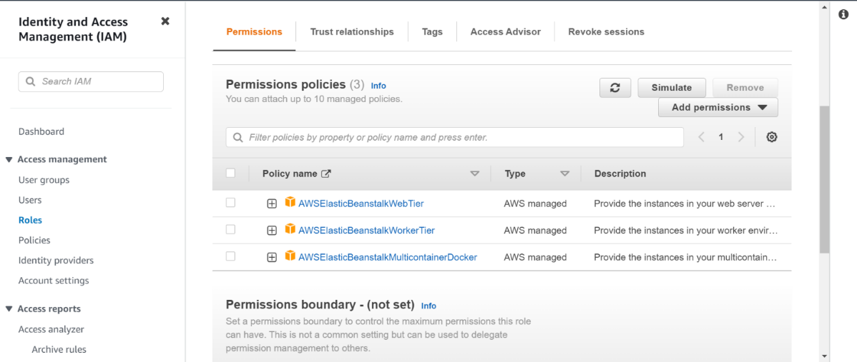](https://i.stack.imgur.com/S5Xoi.png)

Creating Elastic beanstalk

Step1: Configure environment

Select environment tier and name the application

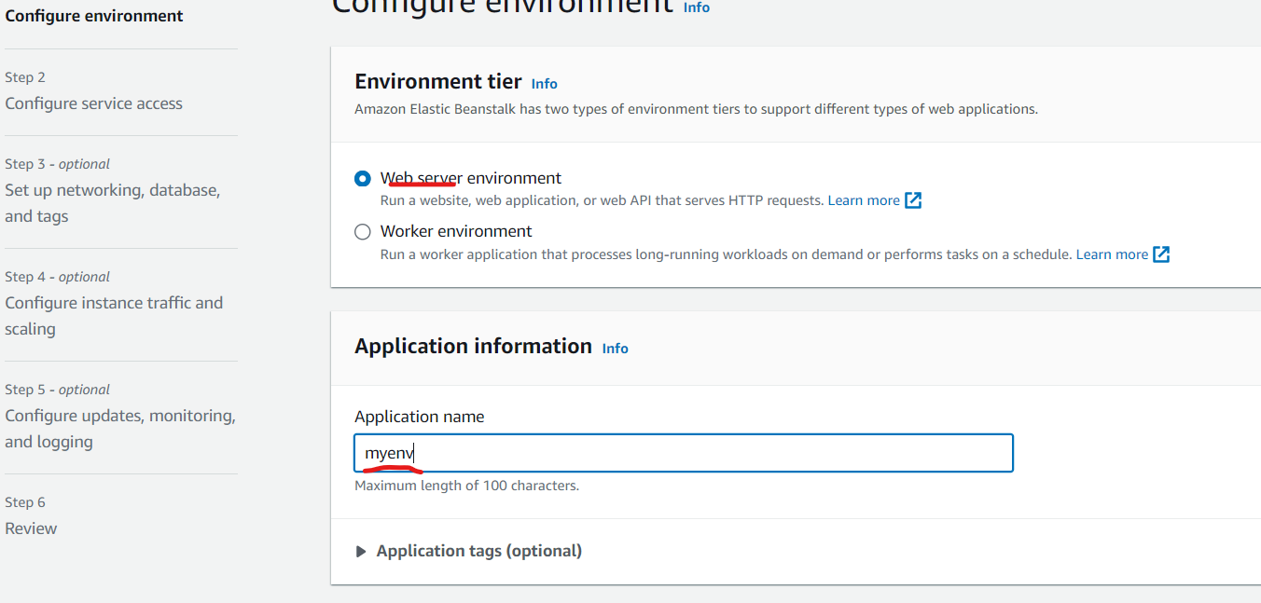

Step2:

Add the platform with version and upload the sample code you need to run and click next

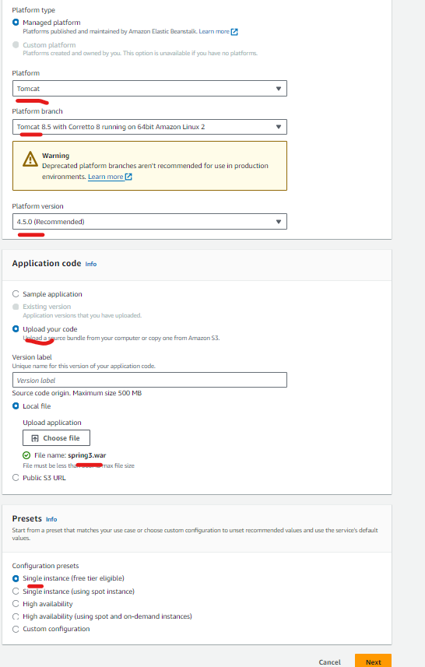

## STEP 3:

## Configure service access:

Add the created IAM roles in existing service roles and ec2 instance profile also add the key pair and click Next

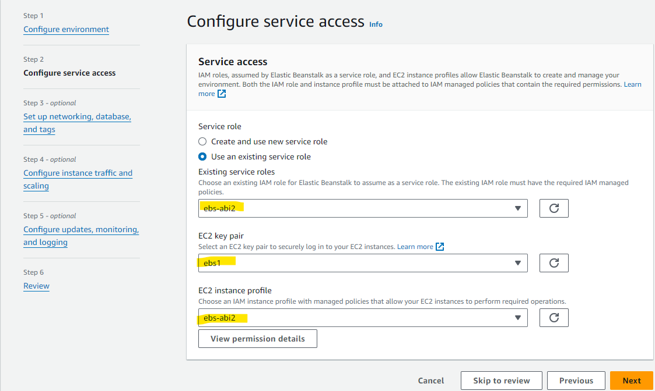

If you want to Set up networking, database, instance traffic, updates, monitoring, and logging follow the below steps or else skip and create environment

1. **References****:**

<https://stackoverflow.com/questions/30790666/error-with-not-existing-instance-profile-while-trying-to-get-a-django-project-ru>